Percentages-Answers
Key Stage 3: 2003 Paper 2 Level 3-5
1.
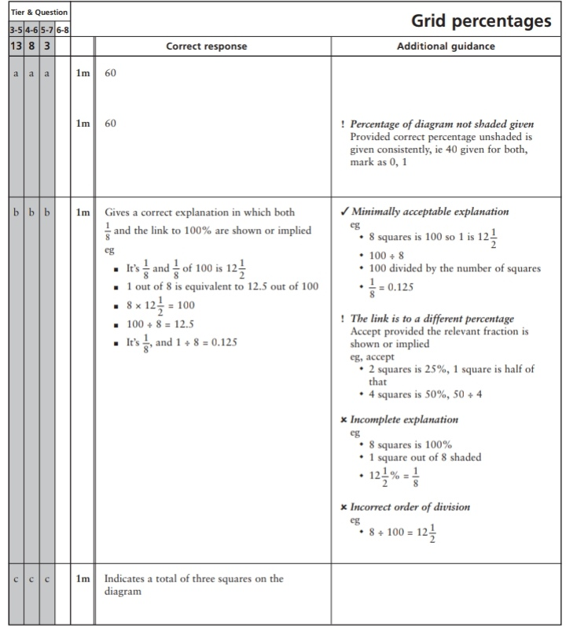
Key Stage 3: 2003 Paper 2 Level 4-6
2.
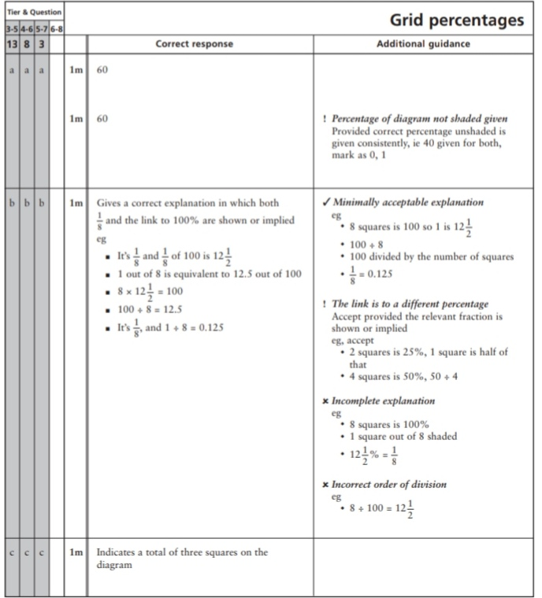
3.
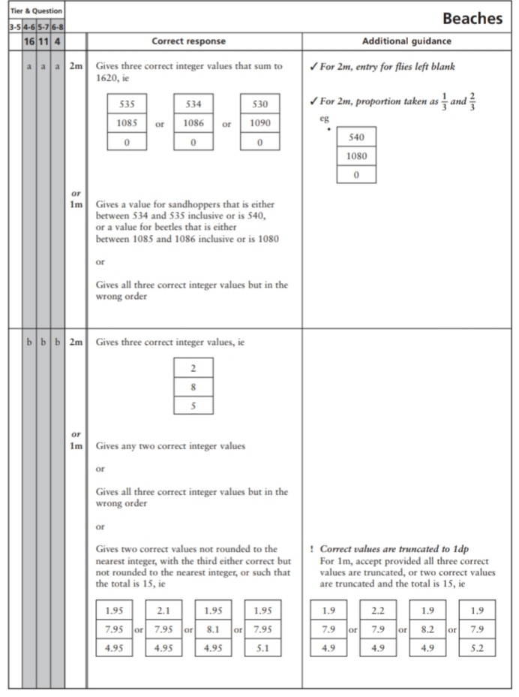
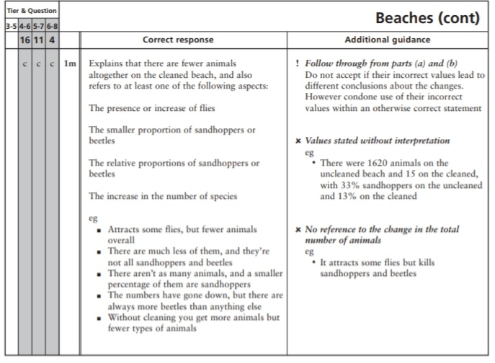
Key Stage 3: 2004 Paper 2 Level 3-5
4.
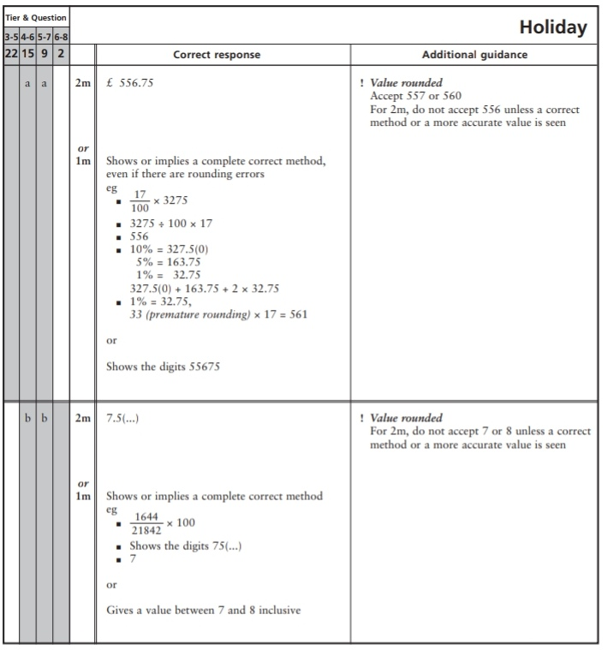
Key Stage 3: 2004 Paper 2 Level 4-6
5.
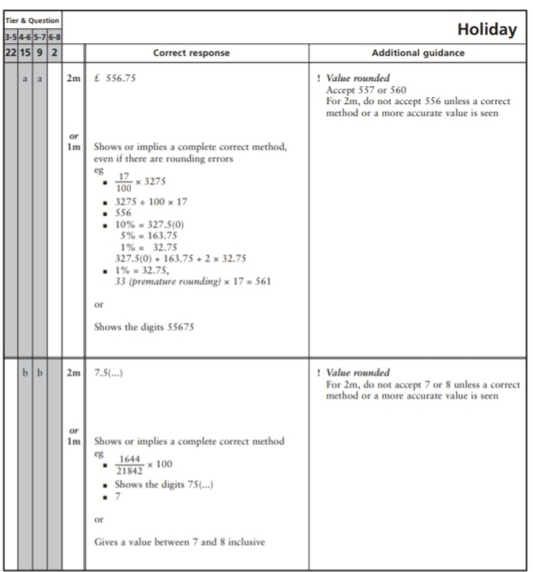
Key Stage 3: 2005 Paper 1 Level 3-5
6.
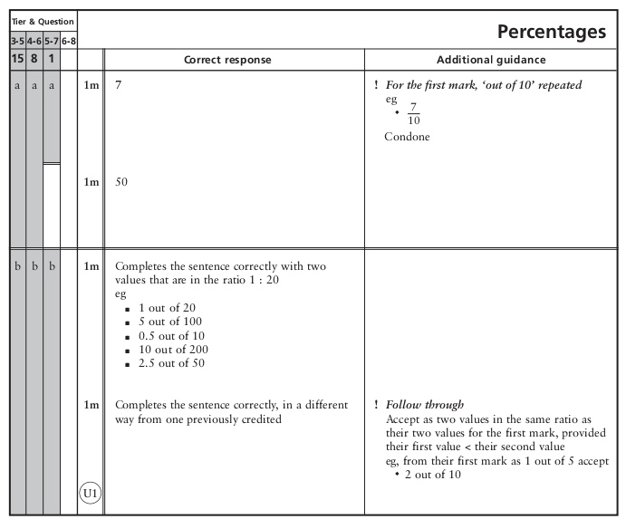
Key Stage 3: 2005 Paper 1 Level 4-6
7.
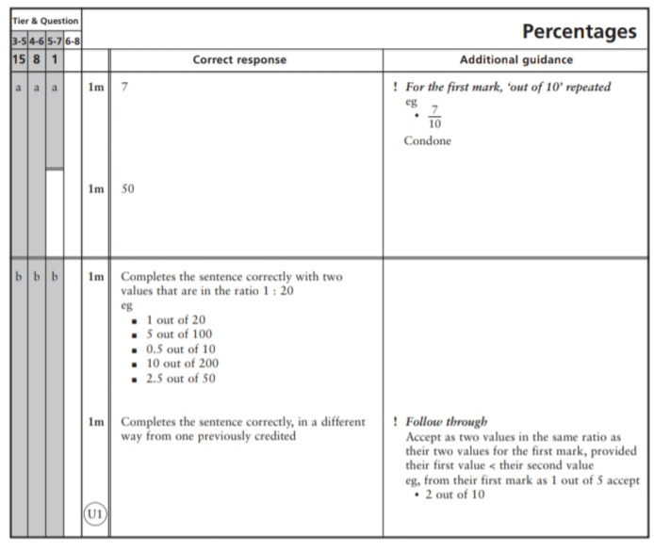
Key Stage 3: 2005 Paper 2 Level 4-6
8.
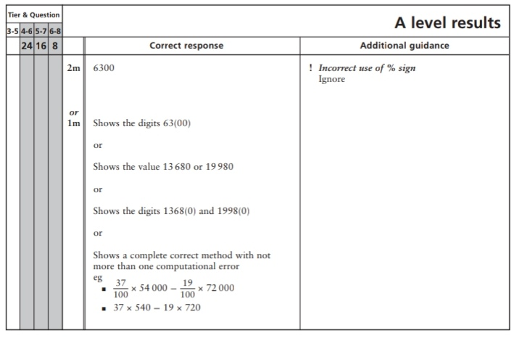
Key Stage 3: 2006 Paper 1 Level 3-5
9.
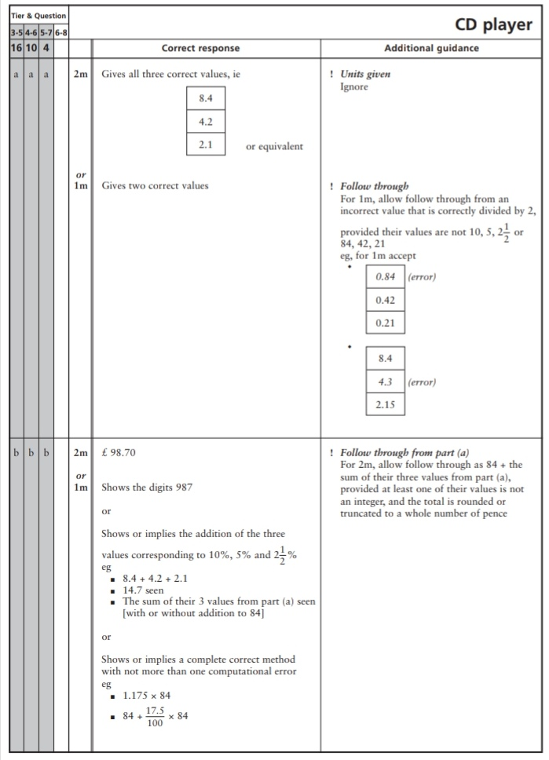
Key Stage 3: 2006 Paper 2 Level 3-5
10.
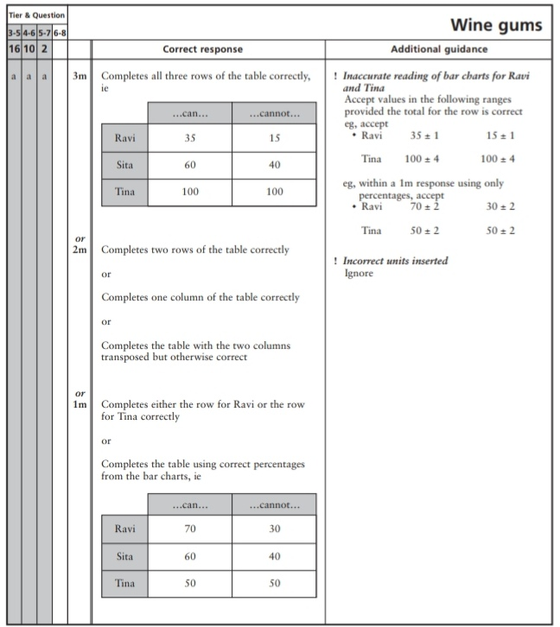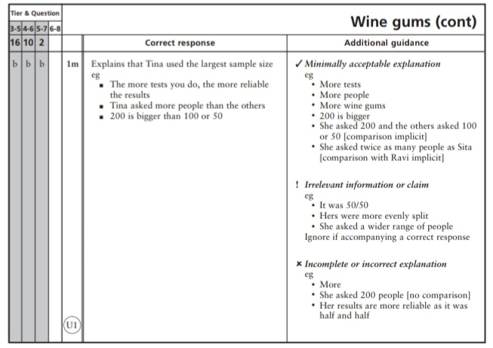
11.
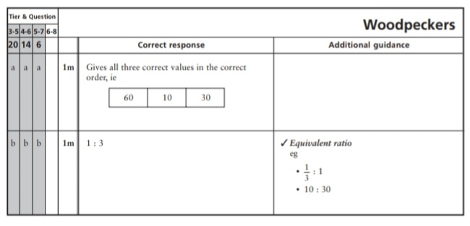
Key Stage 3: 2006 Paper 1 Level 4-6
12.
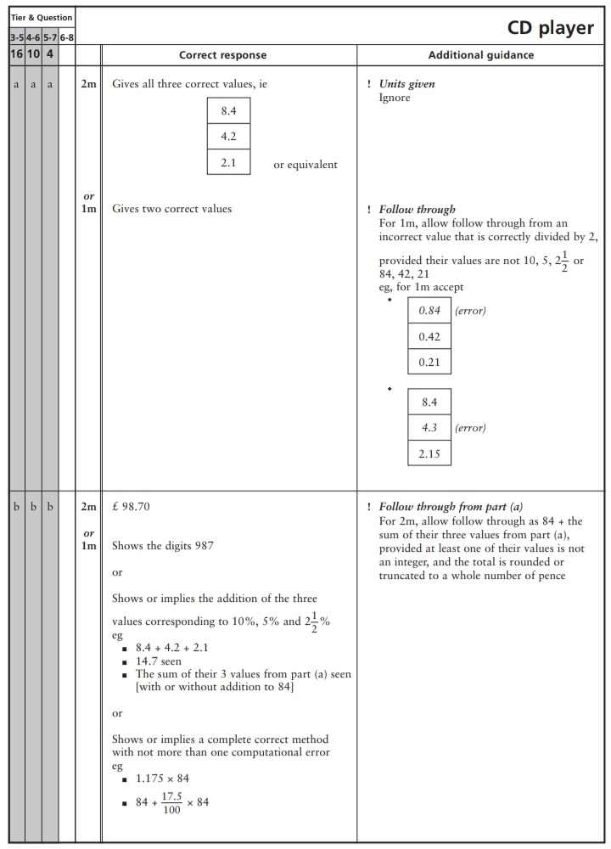
Key Stage 3: 2006 Paper 2 Level 4-6
13.
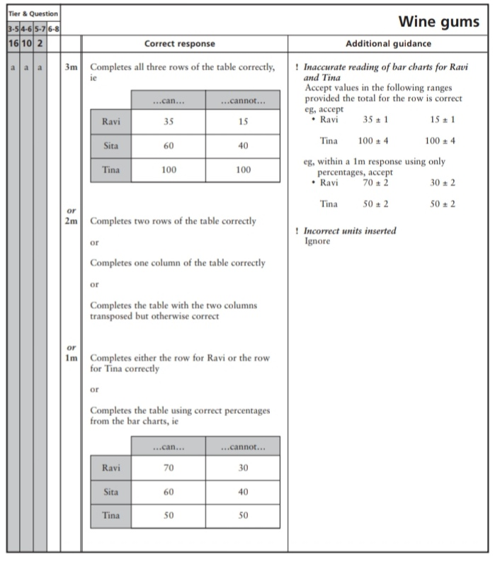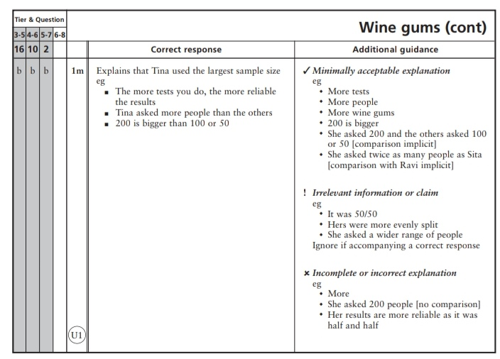
14.
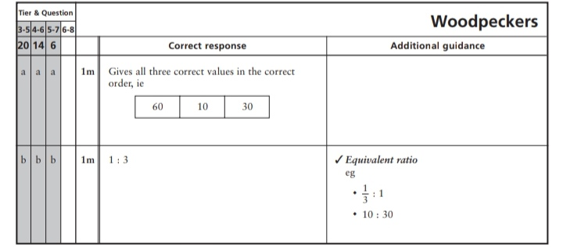
15.
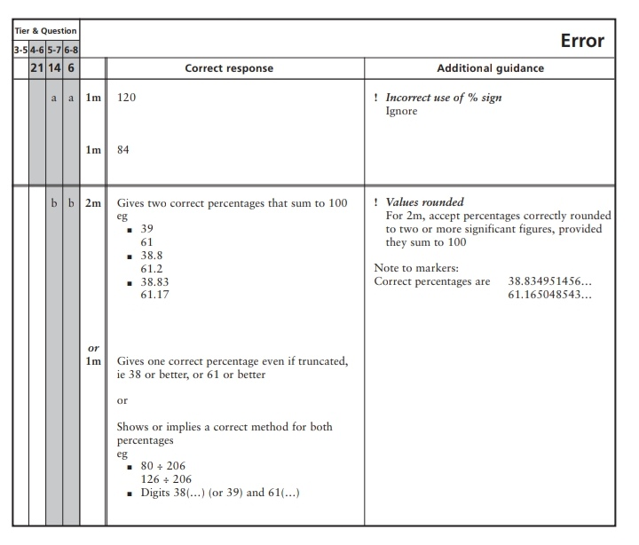
Key Stage 3: 2007 Paper 1 Level 3-5
16.
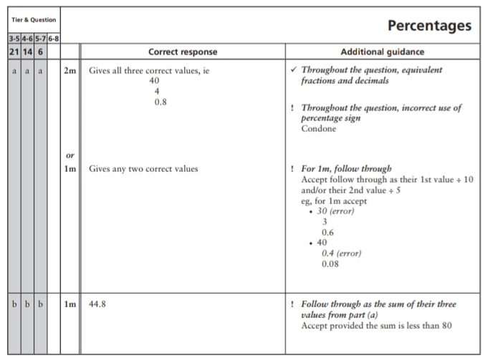
Key Stage 3: 2007 Paper 2 Level 3-5
17.
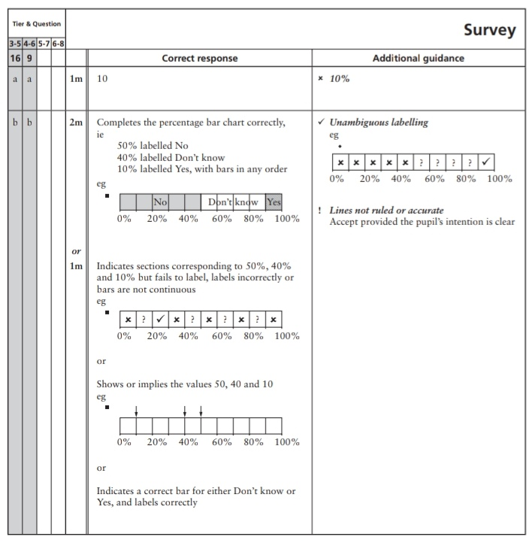
Key Stage 3: 2007 Paper 1 Level 4-6
18.
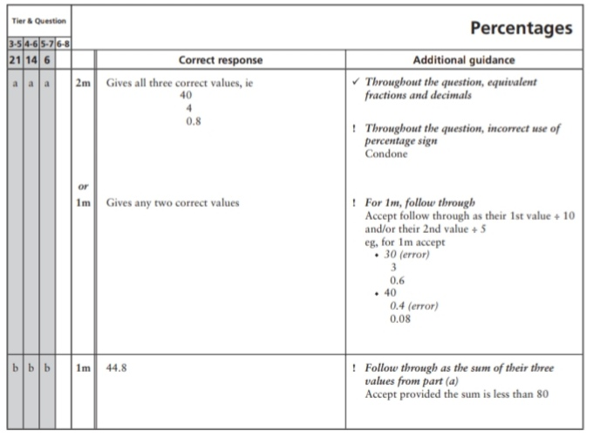
19.
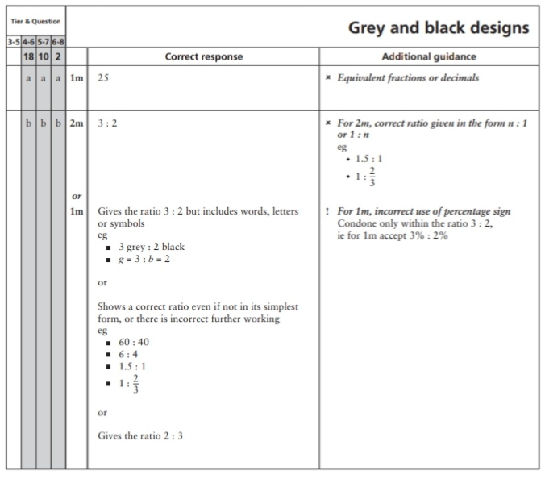
20.
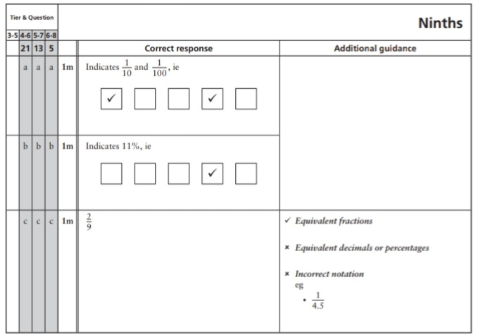
Key Stage 3: 2007 Paper 2 Level 4-6
21.
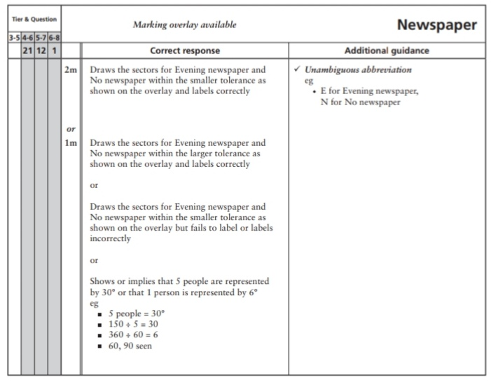
22.
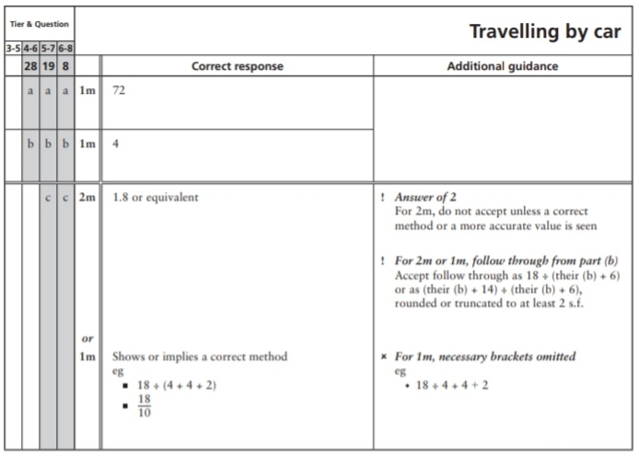
Key Stage 3: 2008 Paper 2 Level 3-5
23.
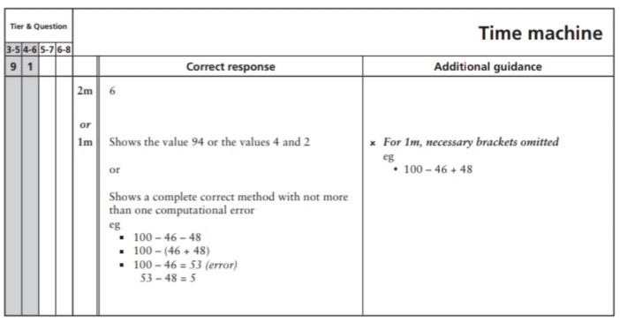
Key Stage 3: 2008 Paper 1 Level 4-6
24.
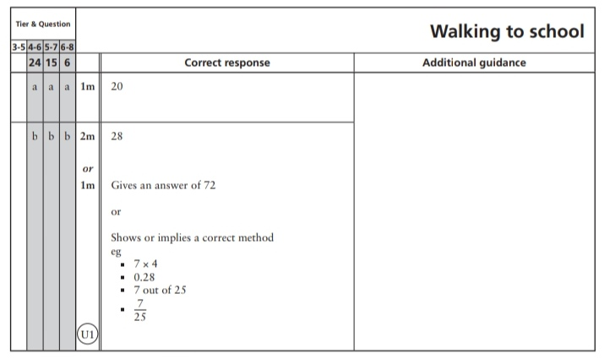
Key Stage 3: 2008 Paper 2 Level 4-6
25.
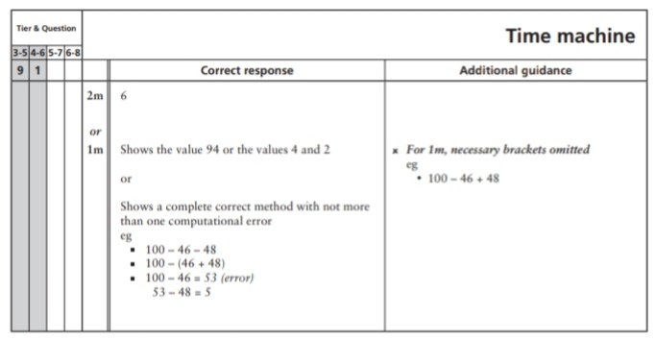
Key Stage 3: 2009 Paper 1 Level 3-5
26.
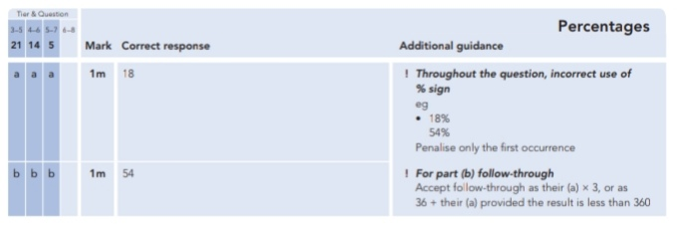
Key Stage 3: 2009 Paper 1 Level 4-6
27.
Key Stage 3: 2009 Paper 2 Level 4-6
28.
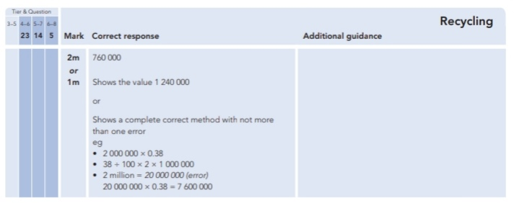
Key Stage 3: 2010 Paper 1 Level 3-5
29.
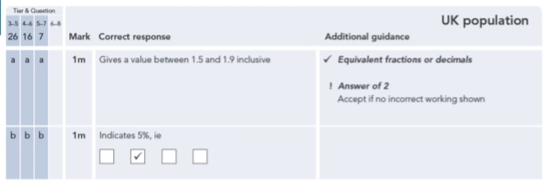
Key Stage 3: 2010 Paper 1 Level 4-6
30.
Key Stage 3: 2010 Paper 2 Level 4-6
31.
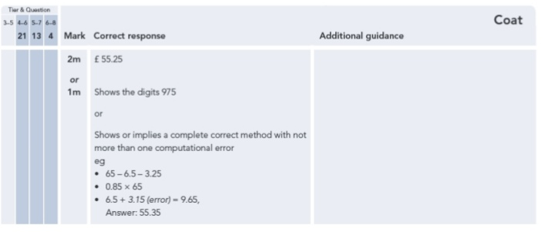
Key Stage 3: 2011 Paper 2 Level 4-6
32.
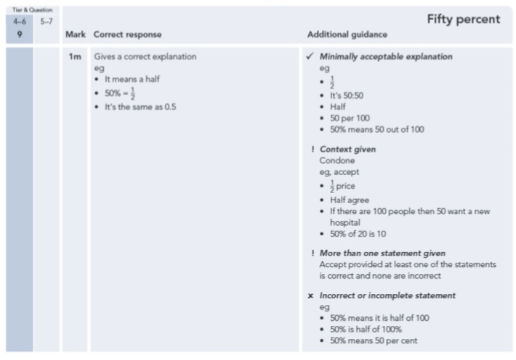
33.
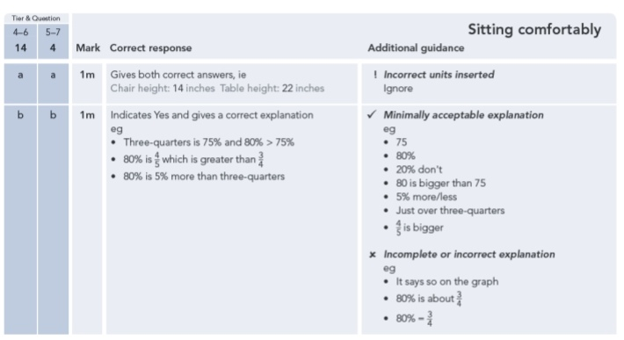
34.
